Day and Night

Chart numbering: The charts are originally numbered as they were in my training, and I’ve also added the corresponding numbering for the “Montessori For Everyone” charts (MFE) when available.

Original impressionistic (hand-drawn) charts: purchase here
Purchase the MFE charts here.

Materials:
- Light bulb with power, representing the Sun
- Globe
- Charts 9a and 10a (MFE 17)

PRESENTATION A: Day and night

Note: This lesson is fun to do in a darkened room, so the children can see the full impact of day and night.

- Place the bulb next to the globe and turn it on. The globe represents the Earth and the light represents the Sun. We can see that the light shines on one part of the globe. The other side of the globe is dark. The Sun can only light up one part of the globe at a time, and that’s the part facing the Sun. Part of the Earth is in the light and part of it is in the dark.

- Spin the globe. We see other parts coming into the light and other parts going into the dark. Because we know that the Earth spins around itself, this change in dark and light happens all the time. There will always be parts of the Earth in the dark and parts in the light. We know this as day and night. (If you have a large group, pick up the globe and move it so it’s on the other side of the light bulb. Then the children get to see the other side of the globe in the light or the dark).

- Point out where the children live on the globe. Keep your finger on it. California is in the light right now. Spin the globe and ask: What is happening now?. It is the Sunset, followed by night. We can see when the light starts to reach California and then we have Sunrise, followed by midday. Then we have Sunset again, followed by night. Invite the children to choose another country and do the same thing.

- So when we say that the Sun is rising or coming up or going down, it’s not really the Sun that is moving. It is actually the Earth, which rotates around itself.

- Show chart 9a/MFE 17

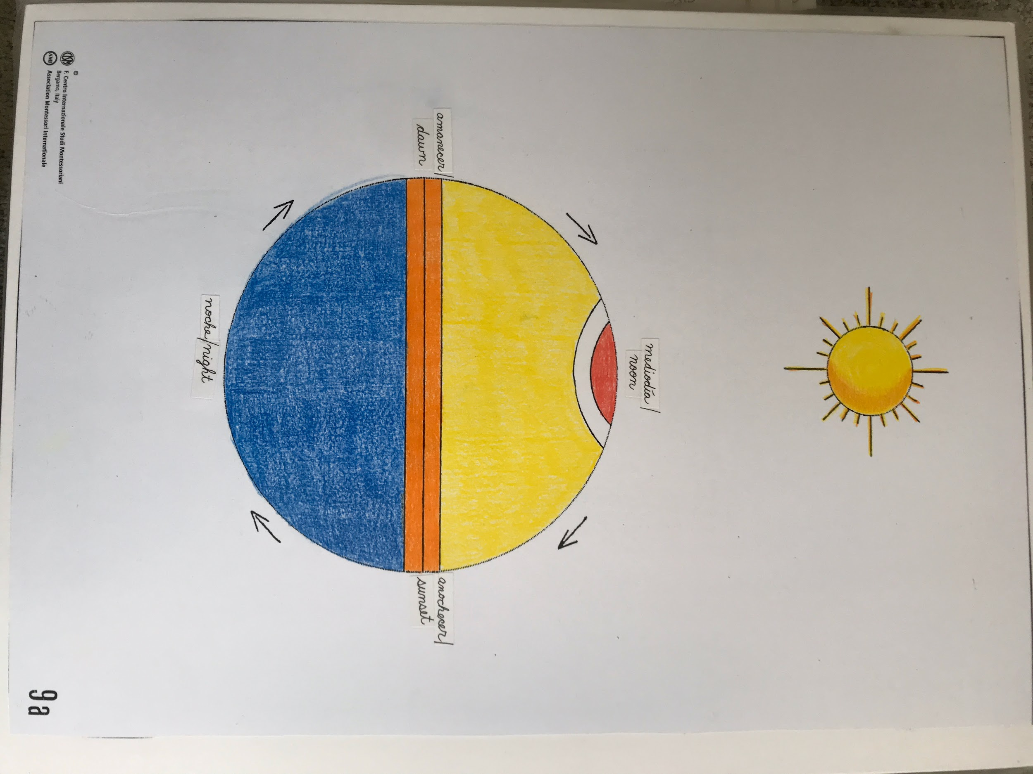
- This is the Earth again. We can see that part of it is in the light and part is in the dark. The part facing the Sun is having noon, or midday. Then it seems like the Sun sinks behind the horizon. We say we have Sunset, and then the Sun seems to be gone. The Sun sets in the west and eventually comes midnight, when you are asleep. Then, eventually some light starts to come again and it is dawn; we say the Sun is about to rise.

- When we have a Sunrise, other parts of the Earth have Sunset. When we have the Sun shining directly onto us at noon, another part of the Earth is having midnight. This happens because the Earth is a sphere that rotates around itself. This complete movement takes 24 hours to happen and it is equally divided. We can say we have 12 hours of light/day and 12 hours of dark/night.

Follow-ups:
- Day/night geography hunt:
  - Take a piece of lined paper and make two columns.
  - With your child, make a list of 6-7 of their favorite countries on the first column and label it “daytime”.
  - Label the second column “nighttime”.
  - Ask your child to put the first country in the “daytime” position on the globe (the country will be facing the lightbulb).
  - Invite them to find a country that’s in the “nighttime” position (on the dark side of the globe).
  - Ask them to write it down on the other column (paying attention to spelling and capitalization).
  - They can continue independently.
.
- Our day and night activities: The children can write when they get up and do certain activities throughout their day. They can notice when it’s AM and when it’s PM. Make this activity fun by making a clock booklet (you can print out blank clock faces or get a clock stamp here.)

- Sunrise/Sunset research: The children can explore the exact time of Sunrise and Sunset in the newspaper or on the computer, and how it changes from week to week.

PRESENTATION B: Coldest and hottest time of day
- Ask the children: Have you ever been camping? When you wake up in the morning while camping, you can feel rather cold. When is the coldest part of our day and night?

- Show chart 10a
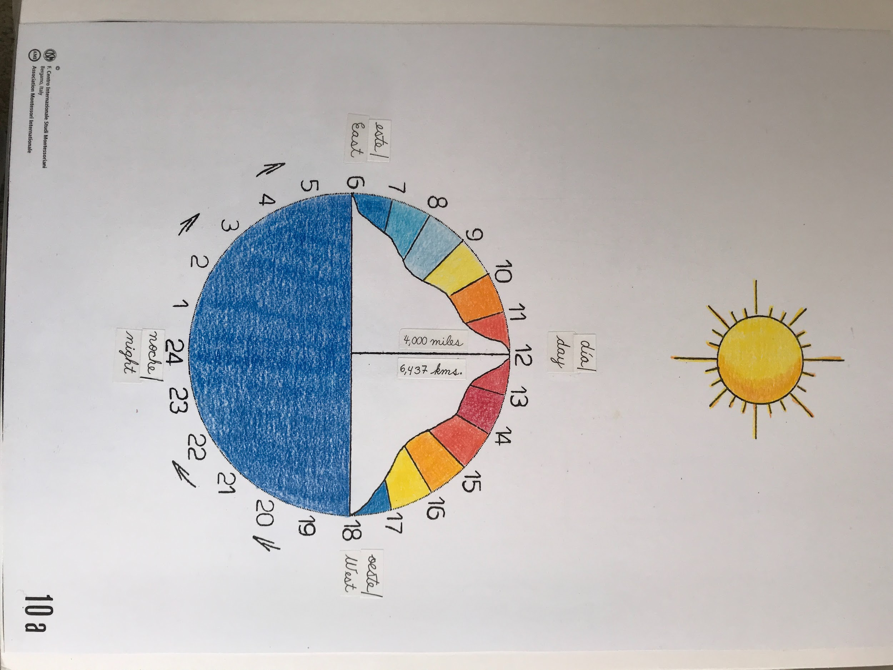

- Suppose the Sun rises in the east at 6AM and moves higher and higher in the sky until 12 noon, which is when the Sun shines directly. Then it seems to sink in the west, and we have Sunset followed by night. We want to find out when is the coldest hour and when is the hottest hour. When do you think they are?

- We might think that midday is the hottest part, because the Sun is shining directly at us. But it isn’t! The hottest part of the day is around 2PM, because the Sun has been overhead for some time and the heat has accumulated. Then we have night, without Sun and only darkness. Lots of us might think that midnight is the coldest part, but for those of us who have slept outdoors, we know that there is a time in the morning that gets very cold because it has been cold for such a long time during the night.

Extensions: There are no formal extensions, but you can keep these concepts in your child’s consciousness by recalling the lessons when you are noticing that it’s the hottest part of the day, when you go camping and sleep outdoors, etc.

